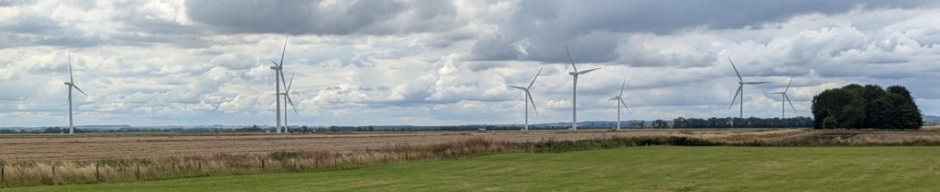

The Constitution of the
Saltfleetby Windfarm Committee

Document History Sheet

Date | Details | Authority
7th July 2025 | First Draft | Approved 2nd Dec 2025

Contents

Heading Page Number

1. Name of Organisation 3
2. Aims of the Saltfleetby Windfarm Committee 3
3. Committee 3
4. Annual General Meeting and Management Committee Meetings 3
5. Rules of Procedure at Meetings 3
6. Finances 4
7. Changes to the Constitution 5
8. Dissolution 5

1. Name of the Organisation

This document comprises the Constitution of the Saltfleetby Windfarm Committee (SWC),
which is an Unincorporated Association.

2. Aims of the Saltfleetby Windfarm Committee

The aims of the Saltfleetby Windfarm Committee are to administer the funds generated by the Gayton Windfarm for community improvement.

3. Committee

The Saltfleetby Windfarm Committee shall be controlled by a Management Committee consisting exclusively of members of the Saltfleetby Parish Council (SPC).

The Chair of the SPC shall be the Chair of the SWC.
The Vice-Chair of the SPC shall be the Vice-Chair of the SWC.
The Clerk/RFO of the SPC shall carry out the duties of Secretary and Treasurer of the SWC.
The rest of the committee shall consist of the remaining members of the SPC.

4. Annual General Meeting and Management Committee Meetings

An annual general meeting will be held in May each year.
Committee meetings will be held on alternate months if required. A schedule of meeting dates will be determined at the AGM.

5. Rules of Procedure at Meetings

5.1 An agenda will be produced by the secretary and disseminated to members one week prior to the meeting and all meetings will be minuted by the secretary.
5.2 Members of the public will be permitted to witness the proceedings but will not be allowed to take part in the discussions.
5.3 The person who signed the application for a grant may introduce the project before the committee determines if a grant will be given. The applicant may be questioned during the debate but other than to answer questions will not take an active part in the debate.
5.4 A committee member who has applied for a grant will be treated in the same manner as a non-member of the committee. ie The member may introduce the project, be questioned by the committee and be present for the voting but will not take part in the voting.
5.5 Grant applications will be forwarded to all members of the committee two weeks prior to the meeting. Only applications that have been forwarded to committee members will be added to the agenda.
5.6 Incomplete applications will be rejected and returned for resubmission.
5.7 Grant applications will be scrutinised in accordance with the terms of reference. All decisions will be made by a simple vote. If the vote results in a tie, then the chair will have an additional casting vote.
5.8 Document hierarchy in the instance of a clash of terms shall be as follows:-

1 Project Funding Agreement dated 14th March 2011
Takes precedence over:-

2 Constitution of the Windfarm Committee (Current Issue)
Takes precedence over:-

3 Windfarm Fund Terms of Reference (Current Issue)

6. Finances

6.1 A dedicated current account will be maintained by the secretary to enable day to day functioning of the Windfarm Fund monies. Additional accounts may be opened to invest surplus and ring-fenced monies.
6.2 A minimum of 10% of the income shall be ring-fenced and invested until the income from the Windfarm ceases. The invested monies may then be used to fund projects after the income has stopped.
6.3 Detailed records of the accounts will be presented at each meeting of the committee by the secretary.
6.4 An annual statement of accounts shall be presented at the Annual General Meeting. The statement will be certified by a competent person who has been appointed by the committee.
6.5 At least four members of the committee will be authorised signatories of the bank accounts utilising internet banking.
6.6 Each transaction will be authorised by two members of the committee.

7. Changes to the Constitution

7.1 The constitution may be amended at the Annual General Meeting or at an Extra-ordinary General Meeting.
7.2 Changes to the constitution must be agreed by a two thirds majority of the committee members.

8. Dissolution

If the Saltfleetby Parish Council is dissolved then the responsibility for the functioning of the Windfarm Fund shall be given to the next tier of government ie District or County Council.

