Annex A
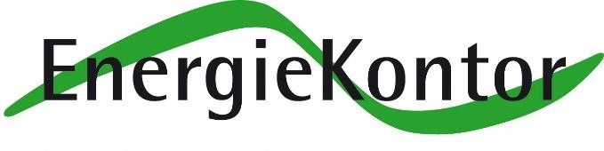
Saltfleetby Parish Council
Wind Farm Fund

APPLICATION FORM FOR GRANT

Applicants, please read the EnergieKontor Wind Farm Fund Project Funding Agreement 2011 and the Terms of Reference Issue 4

(this can be found on the Saltfleetby Parish Council website)

1 Applicant

Name of Group, Organisation or Individual
Contact for this Application
Position Held
Contact Address
Contact Telephone Number(s)
Contacts e-mail Address

2.a Funding Requirement

1. A bursary? Yes/No
2. A group with no formal control? Yes/No
3. An organisation which is regulated by a committee? Yes/No

2.b State the reason why a grant is requested and explain which section of Schedule 1 of the Project Funding Agreement the application meets and how it meets this section.

Section of Schedule 1

- How does the Project meet the Section of Schedule 1?

- Details of Project

3 Documentation

The following documentation should accompany the claim:-

 | Bursary | Organisation | Group
Constitution | No | Yes | No
Date Formed | No | Yes | Yes
Committee Members detailing responsibilities | No | Yes | No
Proof of Public Liability of the venue to be used | No | Yes | Yes
Policies relevant to this application | No | Yes | Yes

4 Costings

Identify the costs of the project and indicate any match funding.
All Items will be accompanied by several quotations or a reason why only one quotation has been obtained.

Item | Cost
Total Cost of Project
Match Funding
Total Cost of Grant

5 Payment

Provide the following:-

Name of Bank
Name of account holder
Account Number
Sort Code
Business or Personal Account

Signature and Declaration of main contact for organisation/group.

I confirm that to the best of my knowledge and belief, all the information is true and correct.
I confirm that two signatories are required for any money transactions. The names of the signatories are

Name | Position Held in Organisation

I understand that you may ask for additional information at any stage of the application process and that all necessary permission for the project has been obtained.

I undertake to ensure that any grant awarded will be used for the sole purpose of the project stated and that if the project does not proceed as specified, all monies received from this fund will be repaid in full.
At the end of the project, I undertake to provide to the Fund Administrator all receipts and relevant financial reports and to report in full at the Annual Parish Meeting.

I confirm that to the best of my knowledge and belief, all information is true and correct. I undertake to ensure that any grant awarded will be used for the sole purpose of the project stated and that if the project does not proceed as specified, all monies received from this fund will be repaid in full.

As an applicant, I consent to my details being stored securely by the Parish Council to
enable the effective management of the EK Wind Farm Community Fund. The data will not be shared outside of the Parish Council.

Yes or No (delete as appropriate)

General Data Protection Regulations (GDPR 2018)

Name  (Block  Capitals) |  | Position in Organisation
Signed |  | Date

IT IS RECOMMENDED THAT YOU KEEP COPIES OF EVERYTHING YOU SEND

Please note the Award Panels decision is final.

Please send the completed application form along with any supporting material to:

Email clerk@saltfleetbyparishcouncil.gov.uk

Grant Application Check Sheet

Before the Grant Application is forwarded to the Fund Administrator you may find it helpful to complete the following check sheet of documentation that should accompany your request:-

Item | Check
Have sections 1 to 5 been completed?
Does the project fit into a category of Schedule 1?
Has the declaration section been completed and signed?
Have quotations been attached to the application?
Has a copy of the Constitution been attached?
Have all committee members been listed with their responsibilities?
Have all relevant policies been attached to the application?

